Lab 5

Given in question

Code

from itertools import product

# Step 1: Define Knowledge Base (KB)

def KB(P, Q, R):

"""

Knowledge Base:

1. Q → P means: not Q or P

2. P → ¬Q means: not P or not Q

3. Q ∨ R

"""

return (not Q or P) and (not P or not Q) and (Q or R)

# Step 2: Define Queries

def query_R(P, Q, R):

return R

def query_R_implies_P(P, Q, R):

return (not R) or P # R → P

def query_Q_implies_R(P, Q, R):

return (not Q) or R # Q → R

def query_notR_implies_Q(P, Q, R):

return R or Q # ¬R → Q

queries = {

"R": query_R,

"R → P": query_R_implies_P,

"Q → R": query_Q_implies_R,

"¬R → Q": query_notR_implies_Q

}

# Step 3: Truth Table Entailment Function

def entails(KB_func, query_func):

print(f"\nChecking entailment for query: {query_func.__name__}")

print("P\tQ\tR\tKB_True\tQuery_True")

all_true = True

for P, Q, R in product([True, False], repeat=3):

KB_true = KB_func(P, Q, R)

query_true = query_func(P, Q, R)

print(f"{P}\t{Q}\t{R}\t{KB_true}\t{query_true}")

if KB_true and not query_true:

print(f"❌ Counterexample found at (P={P}, Q={Q}, R={R})")

all_true = False

break

if all_true:

print("✅ No counterexample found.")

return all_true

# Step 4: Run for each query

for name, func in queries.items():

result = entails(KB, func)

print(f"Result: Does KB entail {name}? -> {result}")

OUTPUT:  
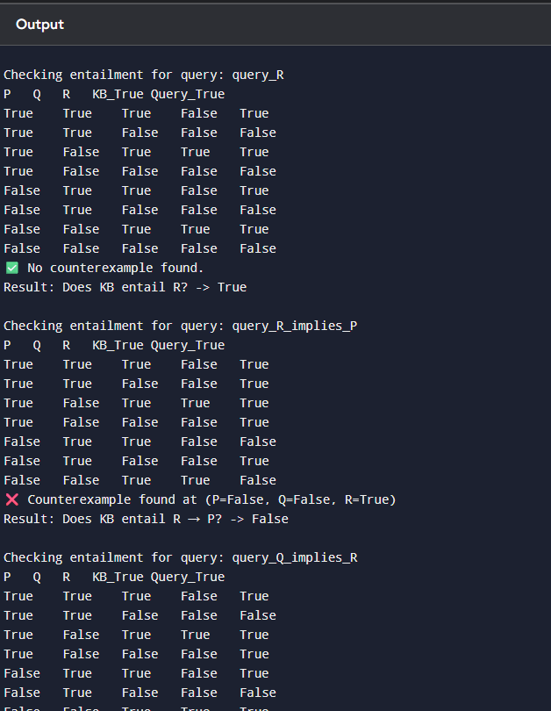

EXAMPLE IN PDF

from itertools import product

# Define individual formula parts

def A_or_C(A, B, C):

return A or C

def B_or_notC(A, B, C):

return B or (not C)

def KB(A, B, C):

# Knowledge Base: (A ∨ C) ∧ (B ∨ ¬C)

return (A_or_C(A, B, C)) and (B_or_notC(A, B, C))

def alpha(A, B, C):

# Query: A ∨ B

return A or B

# Truth table and entailment check

def entails(KB_func, alpha_func):

print("A\tB\tC\tA∨C\tB∨¬C\tKB\tα")

entailment = True # assume KB ⊨ α unless we find counterexample

for A, B, C in product([False, True], repeat=3):

a_or_c = A_or_C(A, B, C)

b_or_notc = B_or_notC(A, B, C)

kb_val = KB_func(A, B, C)

alpha_val = alpha_func(A, B, C)

# Print truth table row

print(f"{A}\t{B}\t{C}\t{a_or_c}\t{b_or_notc}\t{kb_val}\t{alpha_val}")

# If KB true and α false → entailment fails

if kb_val and not alpha_val:

entailment = False

print("\nChecking entailment: Does KB ⊨ α ?")

if entailment:

print("✅ Yes, KB entails α (no counterexamples found).")

else:

print("❌ No, KB does NOT entail α (found a counterexample).")

# Run the truth table entailment check

entails(KB, alpha)

OUTPUT

